EMPLOYMENT opportunities in buckinghamshireS Sport, leisure & PHYSICAL ACTIVITY sectors

  - What does a career in Leisure, Sport and Physical Activity look like?

Introduction
This booklet has been created to support those in education achieve a greater understanding of the opportunities within the Sport, Leisure and Physical Activity Industries and has been created by several leisure operators and sports partners within Buckinghamshire.

Information provided is to the best of our knowledge at the time of publication.


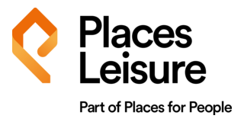


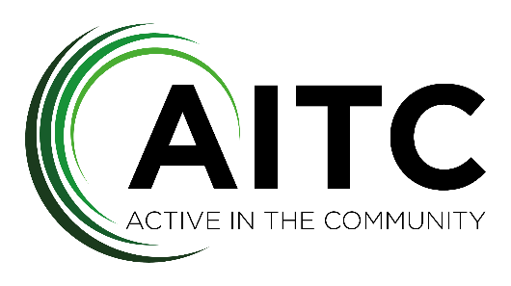



Contents
Introduction 1
Large Recruiters in Buckinghamshire for Leisure 3
Medium Recruiters in Buckinghamshire for Sport and Physical Activity 4
Who are CIMSPA? 5
An overview of the opportunities within the Leisure, Sport and Physical Activity Sectors 7
Career Pathways – Leisure Operator opportunities 8
Case Study 16
Work Experience Opportunities 24
Key Operator/Site Contacts 25

Large Recruiters in Buckinghamshire for Leisure


Everyone Active operates around 240 leisure facilities nationally, ranging from your traditional leisure centre, to theatres, athletics tracks, ice rinks and golf courses.
Locally, Everyone Active operates the Chilterns Lifestyle Centre, in Amersham, alongside Chesham and Chalfont Leisure Centres and employs almost 400 people across these sites.

They also run other nearby centres in Dacorum, St Albans, Three Rivers, Watford and Slough.

More Leisure operates 52 leisure facilities nationally, ranging from your typical leisure facility to ice rinks, golf courses, national centres and water sports centres.
Locally, More Leisure operates Stoke Mandeville Stadium, Aqua Vale, Swan Pool, Evreham Sports Centre, The Beacon Sports Centre and Little Marlow Athletics Track and they employ around XXX across these sites.
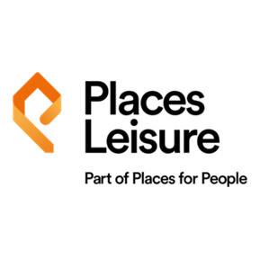
They also run another nearby centre, Bletchley Leisure Centre.

Places Leisure operates 90 leisure facilities across England as well as one in Scotland. These include outdoor lidos, a dry ski slope, outdoor sports and activity centres and more typical leisure centre facilities.
Locally, Places Leisure operate 3 leisure facilities on behalf of Buckinghamshire Council, these are Court Garden Leisure Complex, Risborough Springs Swim and Fitness Centre and Wycombe Leisure Centre.
They employ around 265 staff to ensure the safe operation of all 3 facilities.

Medium Recruiters in Buckinghamshire for Sport and Physical Activity
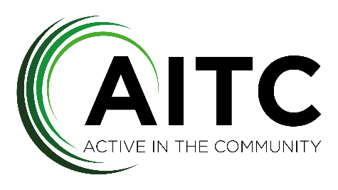
Active in the Community is a not for profit organisation that aims to make physical activity accessible and affordable for all. They operate across Buckinghamshire, Hertfordshire and Berkshire and employ 80 people.
The two main services are ‘Community Projects’ and ‘School Lettings’ and we operate out of 20 venues and locations.

At Leap, we believe that regardless of who you are and where you live, you should be able to benefit from the life changing effects of regular movement. But there are a whole host of complex, connected barriers stopping people from being active. Leap’s mission is to break down these barriers and level up the inequalities.


S4A Group’s mission is to empower all individuals to prepare them for their future opportunities. This is delivered through a wide range of enthusiastic, structured and well-designed activity programmes at affordable prices to impact as many lives as possible. Growing from being predominantly sports centred at the start of our journey to having evolved over the years into an Ofsted accredited, trusted, well established care provider offering a range of services; including wraparound care in many schools, PE lessons, holiday clubs, the HAF programme, SEN support, our football development centre.

Who are CIMSPA?

CIMSPA is the professional development body for the UK’s sport, physical activity and fitness workforce and it’s a registered charity with a Royal Charter. It’s recognised as the authoritative organisation for setting standards, supporting careers, and raising professionalism across the whole sector.
CIMSPA exists to:
- Shape a respected, regulated and recognised sector that employers, professionals and the public can trust.
- Support and develop people’s careers at all levels — from beginners to senior leaders.
- Inspire the nation to be more active by ensuring high-quality professional practice.
CIMSPA defines what skills, knowledge and behaviours are expected for different roles across sport, fitness and physical activity. These standards help create consistency and quality across the industry.
They offer structured membership pathways that reflect career progression in the sector, including:
- Student and Graduate members
- Practitioners (e.g., fitness instructors, coaches, personal trainers)
- Managers and Leaders
- Chartered Members and Fellows — a mark of high achievement and professionalism.
CIMSPA works with awarding bodies and education providers to:
- Endorse qualifications and training that meet its professional standards.
- Ensure training programmes are employer-relevant and aligned with workforce needs.
- Support high-quality continuous professional development (CPD).

CIMSPA collaborates with employers, government bodies (such as Sport England), educational institutions and other partners to:
- Address skills gaps through local skills plans across the UK.
- Provide research, insights and policy leadership on the workforce.
- Lead initiatives that strengthen links between physical activity and public health.
Their long-term strategy (2024–2030) focuses on raising the profession’s visibility and value, ensuring professionals are recognised and supported to have a positive impact on health, wellbeing and community outcomes.
By setting standards and professional pathways, CIMSPA helps:
- Individuals build credible, supported careers
- Employers recruit skilled and reliable talent
- The public be confident that services (like coaching, fitness training, activity leadership) are delivered safely and effectively
- The sector contribute more meaningfully to national health and wellbeing goals.

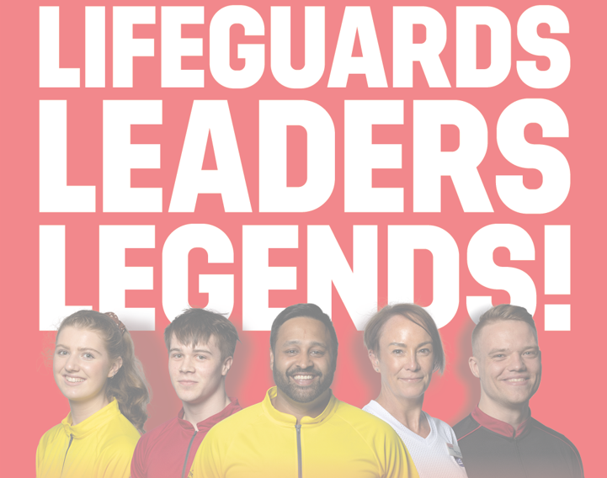
An overview of the opportunities within the Leisure, Sport and Physical Activity Sectors
The Leisure and Sport sectors are fun, varied and fulfilling industries to work within, often starting out by influencing members and users experiences with face to face interactions, whether as a receptionist, café assistant, lifeguard or a activity or sports coach. These initial interactions will ultimately determine, particularly for new users, whether they wish to continue to attend, so there is a direct impact and influence on the health and wellbeing of all those you encounter, whatever your role.
The more people, we and our industry can get exercising regularly (150 minutes of weekly moderate exercise is the Chief Medical Officer guidance), the healthier our communities will become and the less strain there is on our local GPs and healthcare providers, including the NHS as a whole. Should you choose to set out on a career in leisure and sport, whether as a long-term ambition, or as a part time colleague working whilst studying it is important not to lose sight of the potential impact you have on peoples lives. It is also important to note that this responsibility grows with each promotion as you become responsible for a team of people that are the influencers, so you can end up making a sizable and significant impact on your community.
In our opinion, it is the people that make working in Leisure and Sport so great, not just meeting new people with different life experiences each day but being surrounded by like-minded colleagues with a real team ethos to deliver fun, varied and effective sessions and activities that make our customers want to return time and time again. We truly are a ‘people’ businesses and often the cost of colleagues will be the largest spend of any Leisure or Sport organisation, because it is clear without the colleagues, the businesses just doesn’t exist. Therefore, because there are so many roles and so much choice, those that make a good impression and deliver their roles well, both through customer service and work ethic, often get rewarded fairly quickly with additional responsibilities and promotions. We also find colleagues moving between departments and roles regularly as they explore what their colleagues do and find a new point of interest, so even if you think you know the role you are after and its not available, we would always recommend taking and delivering another role well in order to be first-in-line when that other role does come up.
The Leisure and Sport sector is some times undersold and suggested to only non-academic students, but that isn’t a true reflection of the opportunities available. Behind the scenes, the Leisure and Sports Industries, like any other, needs Marketeers, Accountants, Human Resources specialists and Directors and these opportunities do arise, more often than not for those already working in the business in customer facing roles. But whether you are academic or not, our industry does need charismatic, bubbly, outgoing individuals that will get the basics right by offering eye contact, a friendly welcome, following instructions and going above and beyond when the opportunity presents itself. Those that work hard and truly care are likely to get promotions, additional responsibilities and more money and training is often funded should you prove you are worth the investment.
So why not read on into this booklet and explore what a career in leisure might look like for you…

Career Pathways – Leisure Operator opportunities
What are the entry routes and do I need a qualification?
The below flow chart shows the roles available in a Leisure Centre environment in Buckinghamshire, and whilst not every Centre will have all of the facilities, they do exist you may just have to look a little further afield.
As you can see there are no fewer than 19 entry level roles into our industry, suitable for those just starting out. The qualifications required for the roles in blue are outlined on the next page
What qualification do I need?
*NGB = National Governing Body
Are roles hard to come by?
The below flow chart replicates the career pathway chart above but gives an indication of how many individuals may be on site at any one time in each of the roles.
Those marked in red give the indication of the most likely routes into the leisure industry as there is the greatest resource demand for these roles. As with all organisations, the further you move down the chain into roles of responsibility and enhanced pay, the need for you to prove and demonstrate you are the best person for that role increases as there are likely to be several members from a team seeking that promotion.

How much do the roles pay?
The below flow chart replicates the career pathway but now gives indication for the pay brackets for each role and also demonstrates the earning potential within our industry.
The roles in bold text are likely to receive performance related pay or bonus’ for achieving financial targets.

What about Head Office roles?
The flow chart below demonstrates a possible head office structure for a Leisure Operator.
This shows some of the roles that may be available and an indication of pay brackets, whether qualifications are required and within the brackets how many roles are likely to exist per job title.
Again, this demonstrates the variety of role available, and if, for example, your ambition was to be an Accountant and you enjoy sport and leisure, then why not seek this role within our industry?
These roles are likely to be a mix of working from home and commuting into Head Office.

What about a career in Sports and Activity coaching and delivery?
The below flow chart shows the organisational structure of Active in the Community.
This demonstrates how an organisation that is led by its coaches and instructors from a customer facing perspective are supported by a Head Office type structure to ensure that processes for health and safety, people, administration, marketing and finance are handled effectively to enable the business to be set up to win new projects, locations and initiatives whilst providing excellent service for their existing ones.

Active Partnerships are dedicated to promoting sport, physical activity, and movement by addressing barriers and reducing inequalities. Their work ensures that opportunities to be active are inclusive, safe, and accessible to everyone. They provide support and guidance to coaches, clubs, and volunteers, helping create environments where participation is welcoming and sustainable. Active partnerships collaborate with local authorities, health services, schools, and community organisations.
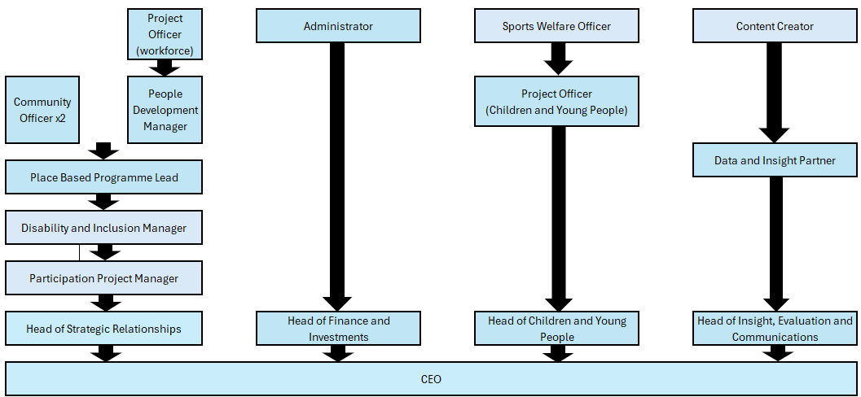

Case Study
Andy the Area Manager

Andy had always been passionate about sports, playing football competitively and enjoying futsal, basketball, cricket, and swimming. His early interest in languages and travel led him to study French and Spanish at university, spending time teaching English in both France and Spain. But it was his part-time work at Farnborough Leisure Centre—starting as a Food & Beverage Assistant and later as a Lifeguard—that sparked a long-term career in leisure management.
After university, Andy returned to Places Leisure Farnborough Leisure Centre, progressing from Duty Manager to Operations Manager roles at Tooting and Camberley. His leadership and operational skills were quickly recognised, and he was seconded as Mobilisation Manager for the launch of Wycombe Contract in 2014. Following the successful opening, Andy was appointed General Manager, where he led the centre through its early years, building strong community engagement and operational excellence.
In 2018, Andy stepped up to become Places Leisure Contract Manager for the Wycombe area, overseeing multiple sites and driving performance across the contract. His strategic thinking and people-first approach helped improve service delivery and team development. In 2024, Andy was promoted to Area Manager, where he now leads a wider portfolio, applying his deep sector knowledge and leadership experience to support site teams and deliver high standards across the region.
Andy has continued to invest in his professional development, completing multiple leadership qualifications including CMI Level 5 and 7, and earning UEFA coaching badges in football and futsal. He’s also a qualified Mental Health First Aid Instructor and National Trainer Assessor for lifesaving and first aid.
Andy’s journey from Food & Beverage Assistant to Area Manager reflects his commitment to growth, his love for sport and people, and his ability to lead with integrity and purpose. He’s proud of the path he’s taken and looks forward to future opportunities to make a difference in the leisure and property management industry.
Case Study
Gavin the General Manager

Gavin had always been sporty and particularly enjoyed playing football and tennis alongside attending his local gym regularly to try and add some
muscle to his naturally slender frame.

Gavin achieved good grades at both GCSE and A-Level and had secured a place at Bournemouth University to study Sports Equipment Design, which combined his two favourite school subjects - Physical Education and Product Design.
However, Gavin deferred his place at University and decided to take a gap year due to personal circumstances. During this year Gavin paid privately to qualify as a Fitness Instructor and Personal Trainer, as his gym sessions had become more regular and he became familiar with the gym team at the local gym, all of which seemed to enjoy their roles and interacting with new customers on a daily basis. These friendships helped Gavin secure a job as a part time Fitness Instructor and he soon found great enjoyment in inducted new members and picking up the occasional Personal Training client.
He quickly decided that this was an industry he wished to work in long term, and further deferred the university place as he picked up a full time role that included the delivery of classes as well as Personal Training. Gavins work ethic, customer service and attention to detail were soon noted by members of the Management Team and he was soon given the project of overseeing the Junior Gym, which was for 8-15 year olds.
Under Gavins guidance this went from strength to strength and he was soon promoted to Gym Supervisor, working closely with the Gym Manager and growing the skillset of the team to develop the Personal Training side of the business. Again, Personal Training began to take off, with customers happier with their results and the team happier with their enhanced pay cheques, this success led Gavin to becoming PT Co-ordinator across two sites to support the other in achieving similar success.
Shortly after this, the Gym Manager position became available, which he was successfully appointed into and at the point the Gym Manager left the sister site, Gavin became the Gym Manager across both sites and was heavily involved in launching a third.
Shortly after the launch of the site, the contract was lost by the current operator and was won by Everyone Active. Gavin made a good first impression and was offered the chance to be General Manager of two small sites - an Athletics Track and a facility that was shared with a School - whilst also continuing to oversee the Fitness department across two sites.
Gavin continued to achieve success and after a couple of years was rewarded with a full time General Manager position at the large site he started out as a member, where he had to navigate the challenges of Covid-19 and the business recovery beyond this. After 18 months running this site James was faced with a dilemma, stay at his local leisure centre, or apply to become the General Manager at a £40m new build just a short drive away.
Gavin took the risk and was successfully appointed at the Chilterns Lifestyle Centre, to open one of Everyone Actives biggest sites, that soon become one of Everyone Actives most successful sites. James is now waiting for his next opportunity, which he hopes will be a Contract Manager role.
Gavin never got round to going to Uni and loves the path his career has taken – he is on a good salary and enjoys the variety of challenges and rewards that each day brings.

Case Study

Freddy the Fitness Manager
Freddy has always been interested playing sports mainly in running and football and started going to the gym in my early teens just to keep fit.
He achieved good grade in GCSE’s and A level and did a Degree in International Accounting and Finance at the University of Northampton.
Once he had got his degree, he decided he wanted to do something else that wasn’t finance based and still liked going to the gym at the time so paid to do his Level 2 Gym instructor and Level 3 Personal Trainer courses.
Once he qualified, he volunteered at the gym he had been attending to gain some valuable experience and to improve his knowledge. When so hours became available at the gym he applied and was successful.
Freddy worked at the gym delivering inductions and personal training sessions as well as classes. After 3 years of working at that gym he transferred to another gym run by the same company and continued the same role there.
While at the new site he was promoted to Gym Supervisor and given more responsibility for the day to day running of the gym, including the gym rota and keeping on top of attrition number and PT income. The current leisure provider then lost the contract, and the contract was won by Everyone Active.
Freddy made a great first impression and was promoted to Fitness Manager of the site. Freddy had a great first year as Fitness Manager and was awarded Fitness Manager of the year for whole South East Region of the company after great success in PT income and Attrition figures.
Freddy continued in his role as Fitness Manager for another year and then was asked to apply for Fitness Manager job at another site which had become available, and this would be a promotion for Freddy as it was a bigger site with more members. Covid 19 hit as Freddy was starting his new job and the leisure centre was shut for several months. Once the leisure centre reopened Freddy started his new role at the new leisure centre as part of his new role he had to Duty Manager for one shift a week as well a manager the gym. As the leisure centre was coming out of covid there wasn’t as many targets to achieve and was more just about keeping the gym as clean as possible.
A couple of years after Covid a new role at the current leisure centre Freddy worked at became available which was Operations Manager for the leisure centre. Freddy applied for the job and was successful. In Freddy’s new job role, he was responsible for Health and Safety and the day to day running of the whole building. Freddy enjoyed his new job role, and it gave him new challenges and also increase his knowledge of things in leisure.
Freddy continued in his role as Operations Manager for another couple of years and then decided he wanted to go back to a Fitness Role.
He applied for a Fitness Manager job at another leisure centre in a different region and was successful in his application.
Freddy settled straight back into the role as Fitness Manager and improved PT income taken at the site over the previous year and kept the attrition level at a good rate and below where they needed to be. After a year Freddy was promoted to Contract Fitness Manager as was now in charge of 3 sites instead of one.
Freddy is currently enjoying his new role and is happy where he currently is and would only be looking for a promotion that would include looking after more sites.

Case Study
Fiona the Finance Manager

From a young age, Fiona found her passion in and around the water. Her journey began with synchronized swimming and lifeguarding, quickly evolving into
a career that would span over two decades. Combining academic achievement (with strong GCSE results) and a vocational path in Travel and Tourism,
Serena’s foundation was both practical and driven by enthusiasm.

At just 16, Serena became a qualified Lifeguard and Swim Teacher, using her skills to work while studying. The water was more than just a job — it was a constant thread through her personal and professional life. These qualifications opened doors internationally, as Serena travelled and worked around the world, always returning to swim teaching in the UK as a reliable and fulfilling career option.
Serena joined her current company as a Swim Teacher 22 years ago, starting with just two hours every Monday. Her dedication, skill, and adaptability saw her grow within the organization, working across three different contracts and taking on increasing responsibilities. Over the years, she expanded her role to include; after-school swim lessons, school swimming curriculum delivery, private lessons for both children and adults and specialised sessions for individuals with learning difficulties and disabilities. This wide-ranging experience allowed Serena to build deep expertise in swim instruction and adaptive education techniques.
With a desire to progress further, Serena enrolled in the company’s Emerging Head of Department training programme, which equipped her with essential leadership skills. This led to her first management opportunity — covering a maternity leave as Swimming Manager, where she successfully led a swim school.
Later, Serena was appointed to lead her own swim school. Under her leadership, the program grew significantly — from 700 to 1,300 swimmers — reflecting her operational skill, customer relationship management, and community engagement.
After years of success in aquatics, Serena made a bold decision to shift her career path taking on a role as a Finance and Admin Assistant. Despite being a significant departure from her previous experience, Serena embraced the challenge. She quickly adapted to new systems, developed business administration skills, and discovered a passion for organizational operations and Human Resources (HR). Her curiosity and eagerness to grow have now turned into a desire to pursue further development in the HR field. Serena was rewarded with a Finance and Admin Manager title, and has recently taken on the role of Contract Finance and Admin Manager, covering 3 sites for maternity leave cover.
Serena’s story is a testament to the power of passion, adaptability, and lifelong learning. From swim teacher to swim school manager to administrative leader, Serena has continuously sought growth while making a lasting impact across different departments. Her journey illustrates how skills gained in one area — such as communication, leadership, and empathy — are highly transferable and valuable in new and unexpected career paths.
As she continues to evolve in her new role and explore HR, Serena remains a shining example of internal progression, talent development, and the rewards of embracing change.

Case Study
Charlie the Contract Sales Manager

Charlie has built a dynamic and well-rounded career within the health, fitness, and leisure industry, underpinned by strong sales expertise, management experience, and a passion for sport and wellbeing. His interest in sport began early, progressing from football to representing his district and county in cricket. Alongside this, he developed an enthusiasm for fitness training from the age of 14.
After achieving a Level 3 Diploma in Sport—completing his studies with a Distinction*—Charlie began his professional journey through a college work placement at a local gym. His performance earned him a two-year apprenticeship, during which he gained his Level 2 Fitness Instructor and Level 3 Personal Training qualifications. He also completed four class-based certifications, enabling him to coach group sessions and build confidence in engaging with diverse members. His progression within the organisation led to an Assistant Manager role, where he first developed leadership and operational management skills. Charlie then chose to deepen his experience in personal training and sales by joining a pre-sale fitness club. This role significantly advanced his sales capability, particularly in a high-pressure presale environment. Within his first two months, he secured 25 weekly personal training clients. Working closely with a varied and high-profile client base—including CEOs and high-net-worth individuals—strengthened his customer service skills and adaptability.
Following the impact of the pandemic and a change in personal circumstances, Charlie transitioned into a membership sales role with an established international fitness brand. He quickly became one of the top sales performers, earning promotion to Assistant Manager. In this role he further developed his leadership, coaching, and people-management skills, contributing to strong team performance and member engagement. After the company was acquired by new owners, Charlie made the decision to pursue new opportunities aligned with his long-term goals.
His next position as Health Club Supervisor allowed him to combine management responsibilities with sales delivery. Overseeing gym staff, reception teams, and spa therapists at a prestigious PGA Golf venue, Charlie sold a wide range of services—including personal training, memberships, spa packages, hen parties, and overnight stays. This role strengthened his ability to problem-solve under pressure, support high-net-worth clientele, and manage multi-disciplinary teams. However, long hours and an unsustainable work-life balance prompted him to seek a role with better stability.
Charlie then joined Serco as a Sports & Inclusive Manager, where he contributed to improving gym standards, developed new sporting activities—including launching a five-a-side football league—and created a new birthday party product that remains in use three years later. His performance led to promotion to Health & Fitness Manager. In this role he delivered improvements across gym operations, class participation, and personal training revenue. His site became a test location for Serco’s commercial training programmes due to its strong results. Following Serco’s success in securing a new local contract, Charlie was appointed Contract Sales Manager—a role in which he has excelled over the past twenty months. He now oversees sales performance across three contracts and has contributed to an exceptional net gain of 1,100 members across one contract this year alone. He also supports the development of new business bids, continuing to expand Serco’s contract portfolio.
Charlies’s career reflects continuous progression, strong sales performance, effective leadership, and a commitment to delivering high-quality customer experiences. He is motivated, commercially minded, and well-positioned to continue developing within contract and sales management across the leisure sector.

Work Experience Opportunities
We have developed a Work Experience programme that we believe will create better experiences and exposure of our industry to students, whilst also meaning that the operator isn’t overwhelmed with having to find additional resource to ‘look after’ work experience students.
Our new programme will include:
- Podcast links to hear about local success stories
- Microsoft Teams meetings with each of the Leisure Operators listed earlier in the booklet to speak about their organisation and career pathway.
- Microsoft Team meetings with those in varying management positions to give insight into their roles and the teams they manage.
- Access to learn about and deliver First Aid
- To try and pass the some of the criteria of a National Pool Lifeguard qualification
- The ability to visit and be toured around the Leisure facilities
- To shadow and assess some roles within our industry to understand the structure of sessions and the key skills of those delivering them
- How to write a CV that sells your skills and experience
- To attend an interview hints and tips workshop
Below is a link to the Work Experience Guide from the Buckinghamshire Skills Hub, this gives a wider overview of work experience opportunities and inspirations in the county.
- Buckinghamshire Skills Hub – Work Experience

Key Operator/Site Contacts
Please include in the subject title of any email ‘Leisure Opportunities in Buckinghamshire – Work Experience’

Everyone Active
Chilterns Lifestyle Centre – JamesSexton@everyoneactive.com
Chesham Leisure Centre – SimonBeddall@everyoneactive.com
Chalfont Leisure Centre – MarleyDowsett@everyoneactive.com

MORE Leisure
Stoke Mandeville Stadium, Aqua Vale, Swan Pool- nicholas.gee@serco.com
Evreham, Beacon, Little Marlow- sarah.norton-cole@serco.com

Places Leisure
Wycombe Leisure Centre - hassanmirza@pfpleisure.org
Risborough Springs - williamknights@pfpleisure.org
Court Garden Leisure Complex - annathurston@pfpleisure.org

Active in the Community
James Cavalier, Director - james.cavalier@aitc.org.uk

